Information & Data Modeling in OGSA Grids
Architecture Paper

Status of This Document
This document provides information to the Grid community on the direction for information and data modeling of OGSA resources. It does not define any standards or technical recommendations. Distribution is unlimited.

Copyright Notice
Copyright ® Open Grid Forum (2006-2007). All Rights Reserved.

Trademarks
OGSA is a registered trademark of the Open Grid Forum.

Abstract
Resources in a grid need to advertise their capabilities, and activities in a grid need to consume those resources. This architecture paper defines the way to model resources’ capabilities and requirements in OGSA grids. It builds on the wealth of existing systems management information already modeled and instantiated in systems today. Examples are included.

Contents

1. Introduction 3
2. Overall Model for Grid Resources 3
3. Model for OGSA Resources 4
4. Example 5
4.1 Systems management instance information 6
4.2 Advertised Capabilities 7
4.3 Activity Requirements 8
4.4 Matching requirements with advertised capabilities 8
5. OGSA Model Architecture 8
5.1 The concrete model architecture and relationship 9
5.2 Representation of resource capabilities 10
5.3 Representation of requirements 11
5.4 Basic set of resource capabilities and properties 12
6. Security Considerations 12
7. Appendix 12
8. Contributors 12
9. Intellectual Property Statement 12
10. Disclaimer 13
11. Full Copyright Notice 13
12. References 13

Introduction
Resources in a grid need to advertise their capabilities, and activities in a grid need to consume those resources. This architecture paper defines the way to model resources’ capabilities and requirements in an OGSA environment. It builds on the wealth of existing systems management information already modeled and instantiated in systems today. Examples are included.

Overall Model for Grid Resources
Modeling resources in a grid has several basic aspects: a reference model, an information model, and a data model. Users – suppliers of models and consumers of models – add their specific managed information to an information model and a data model. It is important to understand the relationship of these aspects to produce and maintain a coherent and consistent model of managed information for grids. Figure 1 depicts these aspects and their relationships.
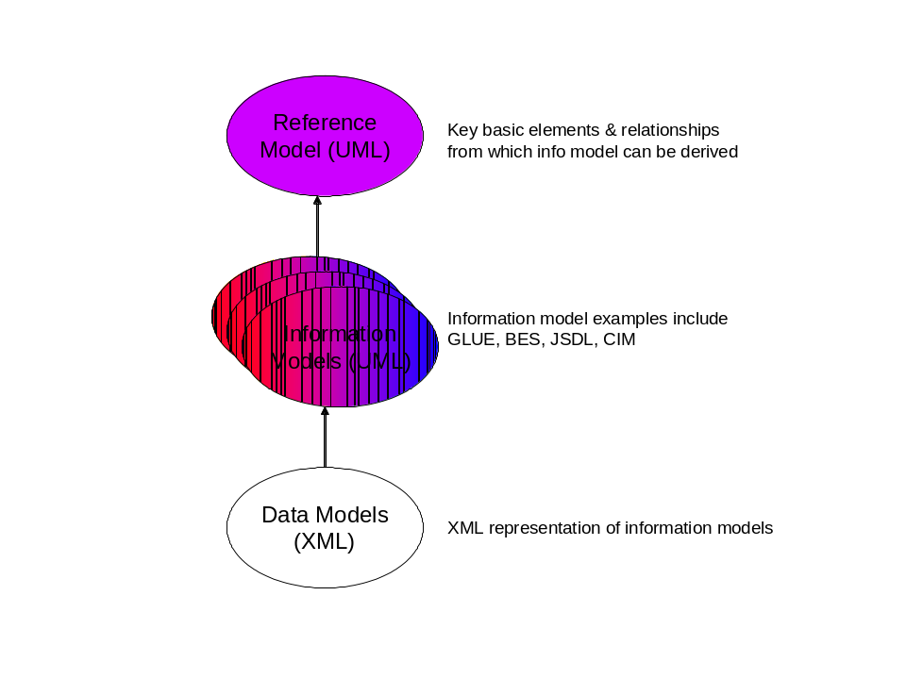
Figure 1. Reference, Information, and Data Model Relationships
The reference model [RefModel] is a very general abstract model in UML that defines a small number of key basic elements and their relationships for grids from which all information model elements for grids can be derived. The reference model also describes a high-level lifecycle model for Grid Components.
The information model is a derivation of the reference model for specific useful, used, and managed grid resources. It is provided in UML. Examples of information models for grid resources are GLUE (basic grid compute and storage resources), Basic Execution Service (BES), and Job Submission Description Language (JSDL). Systems and network information models such as DMTF’s Common Information Model (CIM) also describe elements that may be used in grids.
A data model is a concrete representation of an information model. A data model may have one or more representations. Modeled grid resources have a XML representation.
The OGSA information and data model defines an architecture to maintain a coherent and consistent view among the various model work (at OGF and DMTF) to produce a usable implementation from the distinct piece-parts that are needed for grids, for example, GLUE, Basic Execution Service (BES), Job Submission Description Language (JSDL), and systems/network management models (e.g. CIM).

Model for OGSA Resources
Resources are typically modeled for three reasons: (1) to manage resource information in a system, (2) to advertise the capabilities of resources in a system, and (3) to express a set of requirements such as those needed by a job that is to run in a system.
Today, a system’s resources are typically modeled so systems (including network) management applications can manage (provision, configure, manage, and de-provision) those resources. Information modeled for systems management applications tends to be very granular and detailed. CIM is an example of an information and data model of managed information. Examples of managed information are:
- The processor(s) for each computer with attributes like ProcessorFamily, Version, MaxClockSpeed, CurrentClockSpeed, DataWidth, AddressWidth, Load, CPUStatus, ExternalBusClockSpeed.
- The operating system for each computer (node) and processor with attributes like OSType, Version, LastBootUpTime, LocalDateTime, CurrentTimeZone, NumberOfProcesses, MaxNumberOfProcesses, MaxProcessesPerUser, TotalSwapSpaceSize, TotalVirtualMemorySize, FreeVirtualMemory, FreePhysicalMemory.
- Each computer (node) with attributes like Name and NameFormat (e.g. DNS style hostname), Load.
- Relationships between elements of the above information to express, for example, that a given computer has n processors, has 1 or more installed operating systems, and one of those installed operating systems is actually the running operating system.
- Values of attributes are typically discrete values and specific
Figure 2 depicts this usage from both the ‘manage’ and the ‘use’ points of view.
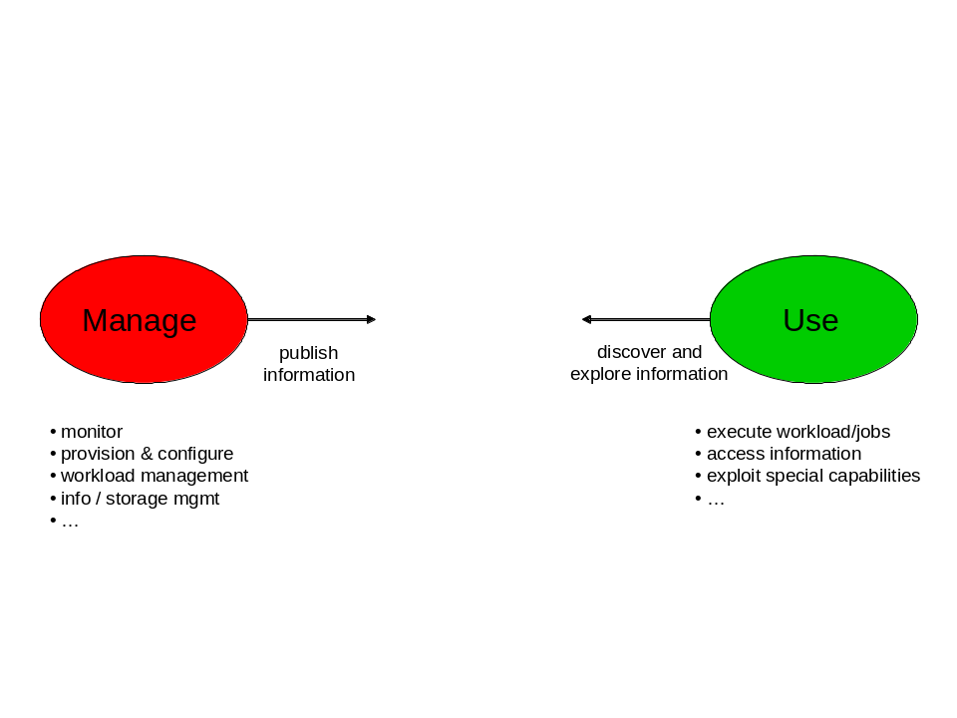
Figure 2. Resource Usage
In grids, a job (or in the more general sense – an activity) needs to run where its resource requirements are satisfied or can be provisioned to satisfy those requirements. To make that determination, systems in grids need to advertise the capabilities of its resources. Activities that are run in a grid may be, for example, parallelized applications and run on multiple nodes in the grid. So requirements may need to be expressed for multiple resources of the same type (e.g. Activity A needs a minimum of three processors with n CPU seconds (or m seconds of wall clock time) available) as well as total CPU seconds or wall clock time for that activity. Therefore, these requirements and capabilities need to be expressed in terms that are meaningful to the activity’s writer (e.g. user friendly). A requirement’s values may be discrete or may be a range of values.
A study of the way in which managed information is modeled for systems management and how resources are modeled in grids to express requirements and capabilities leads one to conclude that the systems management type of model for information modeling of resources is not what’s needed in OGSA grids. Instead, a higher level, less granular, and more user friendly information model is needed to express an activity’s requirements and to advertise a resource’s capabilities. However, since managed information exists in systems today, it is beneficial to determine a resource’s advertised capabilities from that existing managed information. Figure 3 proposes the relationship between a system’s managed information and a grid’s need to advertise resource capabilities and an activity’s requirements to consume resources.
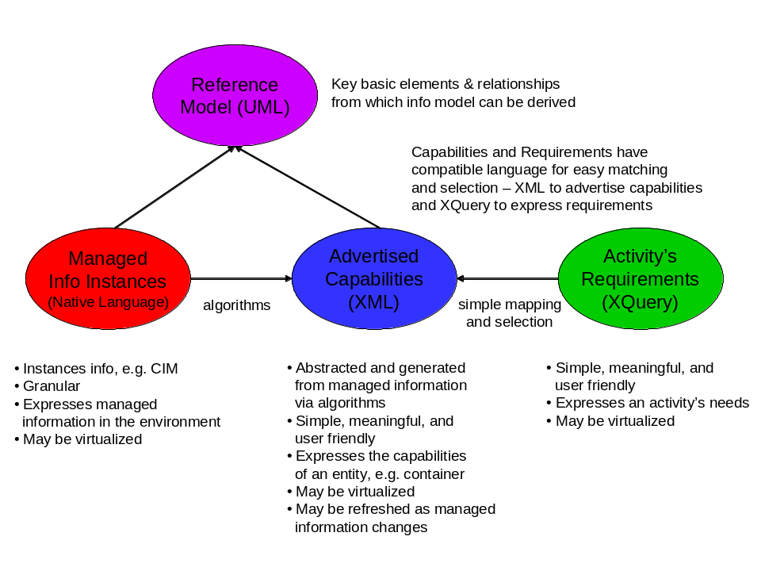
Figure 3. OGSA Model Concept
Capabilities are abstracted and generated from managed information via algorithms. These capabilities are updated as the managed information in the system changes. An activity’s requirements are matched against the advertised capabilities to determine which resources it will consume and hence where that activity can execute. These capabilities and requirements use compatible languages for easy matching and selection of resources – XML to advertise capabilities and XQuery to express requirements.
There are two categories of capabilities that can be advertised. The first category is capabilities that are typically consumed by an activity such as an application. These capabilities typically have static values, e.g. total physical memory or operating system type. The second category is capabilities that are typically consumed by some system component such as a job manager. These capabilities may be static or may change as activities are executed, e.g. available physical memory, load.

Example
This example shows the managed information in a system (using CIM), the capabilities advertised (using GLUE) from that system that an activity can consume, and the activity’s requirements (using JSDL) that are matched against the advertised capabilities. In this example, the activity is some application with a JSDL document, and the capabilities advertised are those that may be typically matched against a JSDL document. Capabilities that a system component may want to consume are not advertised in this example.
The example below is provided in English text for ease of use by the reader. In practice, it would be implemented in XML/XQuery format consistent with the information models being developed in OGF workgroups.

Systems management instance information
The system management information consists of the following:
Computer A has DNS-style hostname, Name=computerA.acme.com. It is classified as a non-dedicated system (ability to run applications, store data, act as a router or gateway, etc) with attribute Dedicated=0. Likewise, Computer C has a DNS-style hostname, Name-computerC.acme.com and the same characteristics as Computer A.
Computer B has DNS-style hostname, Name=computerB.acme.com. It is classified as a router with attribute Dedicated=4.
Computer A has 1 processor and Computer C has 2 processors. Each processor instance has the following managed information:
- ProcessorFamily=118 (AMD Athlon 64) for Computer C and ProcessorFamily=185 (Intel Pentium M) for Computer A
- UpgradeMethod=16 (Socket 754)
- MaxClockSpeed=3200 MHz
- CurrentClockSpeed=3000 MHz
- DataWidth=8 bit
- AddressWidth=32 bit
- Load=50% (Computer A – processor 1), Load=73% (Computer C – processor 1), Load=30% (Computer C – processor 2)
- Version=3.1.c
- ID=975403-2 (Computer A – processor 1), ID=984567-3 (Computer C – processor 1), ID=967021-8 (Computer C – processor 2)
- CPUStatus=1 (CPU enabled)
- ExternalBusClockSpeed=800 MHz (front side bus)
- Characteristics=2 (64 bit capable)
Computers A and C each have operating systems Windows XP Service Pack 2 and Linux installed. Computers A and C are currently configured and running the Linux operating system. Managed information for the current running Linux operating system is:
- OSType=36 (Linux)
- Version=2.1.f (major.minor.revision)
- LastBootUpTime=20060501
- CurrentTimeZone=-6 (CentralUS)
- NumberOfUsers=4
- NumberOfProcesses=67
- MaxNumberOfProcesses=0 (no maximum)
- TotalVirtualMemorySize=amt of total RAM + amt of paging space (SizeStoredInPagingFiles)=12000000 KB
- FreeVirtualMemory=amt of free RAM + amt of free paging space (FreePhysicalMemory + FreeSpaceInPagingFiles)=4100000 KB
- FreePhysicalMemory=100000 KB
- TotalVisibleMemorySize (amount of physical memory allocated to this OS)=4000000 KB (4GB)
- SizeStoredInPagingFiles=8000000 KB
- FreeSpaceInPagingFiles=4000000 KB
- MaxProcessMemorySize (max bytes allocated to a process)=1500000 KB
- MaxProcessesPerUser=32
Computer B has 1 processor of type Intel running Windows XP operating system. The details for Computer B are not stated here because that computer is classified as a router and will not run activities. So for this example, the advertised capabilities are minimal (in reality, it does advertise more than the minimal capabilities listed in this example).
Some values of this managed information are static for the life of the instance (e.g. hostname, operating system type), and some values change over time (e.g. processor load, free memory (physical, virtual, page space)).
This instance managed information will not be presented in XML in this example because different models have different XML representations. The representation of this managed information is not the focus of this position paper – what matters in this example is that this managed information exists and can be used to generate a resource’s advertised capabilities.

Advertised Capabilities
Computers A and C advertise their capabilities as a stated below. These capabilities are algorithmically generated from granular detailed managed information. For this example, the detailed managed information is from CIM and the resulting advertised capabilities (names and unit values) are from GLUE. Some capabilities may map almost one-to-one with the managed information, e.g. the units of the value are different (CIM memory elements are kilo-bytes and GLUE memory elements are bytes). Some capabilities are computed from one or more pieces of managed information, e.g. MainMemorySize for a machine with 2 processors that is advertised as available for 1 or more activities is the computation (TotalVisibleMemorySize for processor 1 + TotalVisibleMemorySize for processor 2).
Computer B is dedicated to routing and will not execute work (activities). Computers A and C can execute work (activities) because there is not an advertised work restriction.

- Hostname=computerA.acme.com
- Processor
- CPUVendor=Intel (could include CPUModel and CPUVersion to qualify further)
- CPUClockSpeed=3200 (units are MHz)
- OSName=Linux
- MainMemorySize=3000000000 (units are bytes)
- VirtualMemorySize=12000000000 (units are bytes)

- Hostname=computerC.acme.com
- Processor
- PhysicalCPUs=2 (could include CPUModel and CPUVersion to qualify further)
- CPUVendor=AMD
- CPUClockSpeed=3200
- OSName=Linux
- MainMemorySize=3000000000 (units are bytes)
- VirtualMemorySize=12000000000 (units are bytes)

Computer B advertises (minimally for brevity in this example) its capabilities as:
- Hostname=computerB.acme.com
- Dedicated=router (not in GLUE, but included from CIM for this example)
- Processor
- CPUVendor=Intel (could include CPUModel and CPUVersion to qualify further)
- OSName=WindowsXP
- MainMemorySize=8000000000 (units are bytes)
- VirtualMemorySize=20000000000 (units are bytes)

Activity Requirements
Activities 1 and 2 list their resource requirements needed to execute. These example requirements (names and unit values) are from JSDL. These resource requirements are mapped against advertised capabilities to determine which resources this activity will consume and hence where the job will run.

- Activity1
- CPUArchitecture=x86_32 (no way to state “AMD or Intel; perhaps not important?)
- TotalCPUSpeed >2500000 and <3500000 (units are Hertz)
- OperatingSystemType=LINUX
- TotalPhysicalMemory=2000000000 (units are bytes)

- Activity2
- CPUArchitecture=x86_32 (no way to state “Intel; perhaps not important?)
- TotalCPUCount<=2
- IndividualCPUSpeed>3000000 (units are Hertz)
- OperatingSystemType=Windows_XP

Matching requirements with advertised capabilities
A system component, such as a job manager, will match an activity’s requirements against resources’ advertised capabilities to determine the possible place(s) that activity may execute.
Activity 1 can execute on either Computer A or Computer C.
Activity 2 can execute on Computer A if that computer is re-provisioned to run the Windows_XP operating system.

OGSA Model Architecture
To move from the concept described above to a concrete architecture (and implementation), the following items form the architecture or pattern.
- Relationship to detailed systems/network management detailed models (Figure 3. OGSA Model Concept)
- A concrete advertisement / requirement model: approach based on Condor class-ads (Figure 4. OGSA Model Architecture and Figure 5. Advertisement-Requirement Matching)
- Representation of resource capabilities: a simple XML document format (Figure 5. Advertisement-Requirement Matching)
- Representation of requirements: a usable subset of XQuery ()
- Basic set of resource capabilities and properties from which to extend

The concrete model architecture and relationship
Figure 4 shows the concrete OGSA model architecture and its relationship to systems management models.
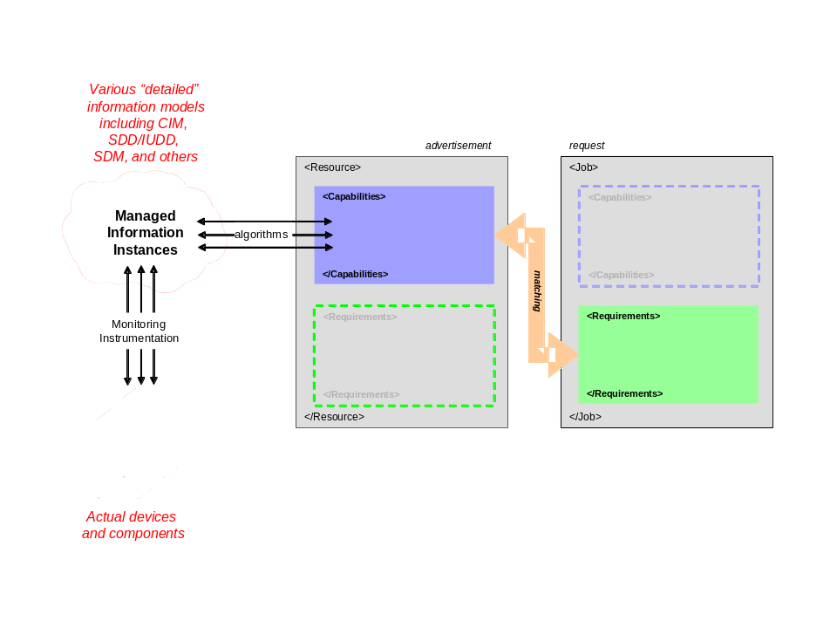
Figure 4. OGSA Model Architecture
Resources advertise capabilities – physical, logical, and generated. These capabilities are abstracted from detailed systems management information via algorithms. Some capabilities are static, others are dynamic. Those that are dynamic are refreshed as their values change or are created/deleted per their lifespan. Jobs (or activities) specify their requirements and are matched against capabilities resources advertise to determine placement, execution, etc.
Taking this one step further, resources also have a need to express requirements (e.g. policy) and jobs (or activities) also have a need to express capabilities (e.g. identity). The concrete model allows for this symmetry as shown in Figure 5. It is recognized that there are specifications in place for things like policies and identification – this architecture is not meant to replace any of those specifications but rather to note that policy and identification are an integral part of the concrete model and further investigation needs to occur to understand how best to convey that information with respect to resources and jobs (or activities).

*** Need to align GLUE document structure advertisement (capabilities and requirements) structure. Working assumption should be that GLUE represents the blue bubble (advertisement). In degenerate case, GLUE may also represent red bubble (if CIM view classes actually happen). Need to work with DMTF to make CIM view classes happen as that will most likely be the easiest way to start the transformation of managed information in the red bubble to advertised capabilities in the blue bubble. Also need to see what alignment can be made between GLUE, JSDL, and potentially BES given the example in section 4 that clearly points out that there are mismatches in basic resource names and units that will create much trouble in matching between advertised capabilities (blue bubble) and activity requirements (green bubble).***

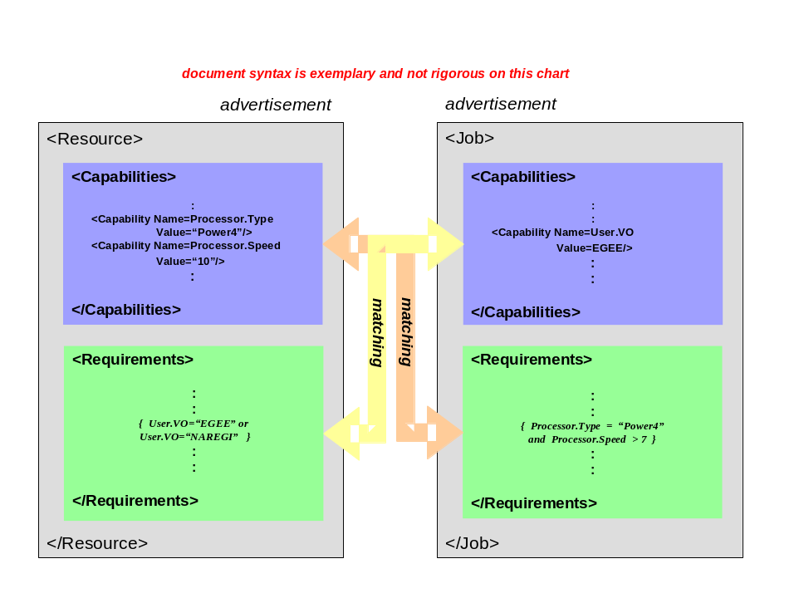
Figure 5. Advertisement-Requirement Matching

Representation of resource capabilities
Resource capabilities are represented in one or more XML documents. This provides the user/developer/tooling a declarative format. Capabilities are expressed as name-value pairs, that is, capability is a name and property is its value. Most capabilities can be expressed in a 2 level hierarchy for simplicity, although the hierarchy is not limited to 2 levels. The XML document can either be stored natively (as XML document) or in a relational table (nice for searching and matching). Most database systems today support XML document to relational table conversion. The concrete rendering uses XSD schema and XML typing. In XML typing, reuse of element names requirements use of namespaces. The <any> construct is used for extensibility in XSD. Extensions can be derived from existing models and the OGSA basic resources. And existing XML models can be included in the XML document. Because typing an XML document can be tedious and error-prone, this representation and its characteristics for resource capabilities was chosen to capitalize on existing tooling for generation and validation to quickly seed adoption.
is an example of rendering a few resources (physical) in this representation. Logical and generated resources also use this rendering. Two important aspects of the rendering are semantics and abstracted usable properties. For example, the CPU speed varies by vendor. From the user’s point of view, he is more interested in a relative abstracted value rather than having to figure out how to identify which processors from different vendors satisfy his speed requirements. Hence, there is a defined semantic associated with the value ‘10’ of property ‘Speed’. These types of abstractions and semantics are documented as part of the model, ideally as part of the defined resource capabilities. Likewise, any algorithm used to generate this abstracted capability is documented as part of the model.
*** Need to update Figure 6 based on XML alignment of GLUE XML representation and OGSA advertisement structures. Propose that this example be a cleaned up version of some of the previous OGSA xQuery example charts () that incorporate the English text example in section 4 of this document per section advertisement structure with GLUE XML representation. ***

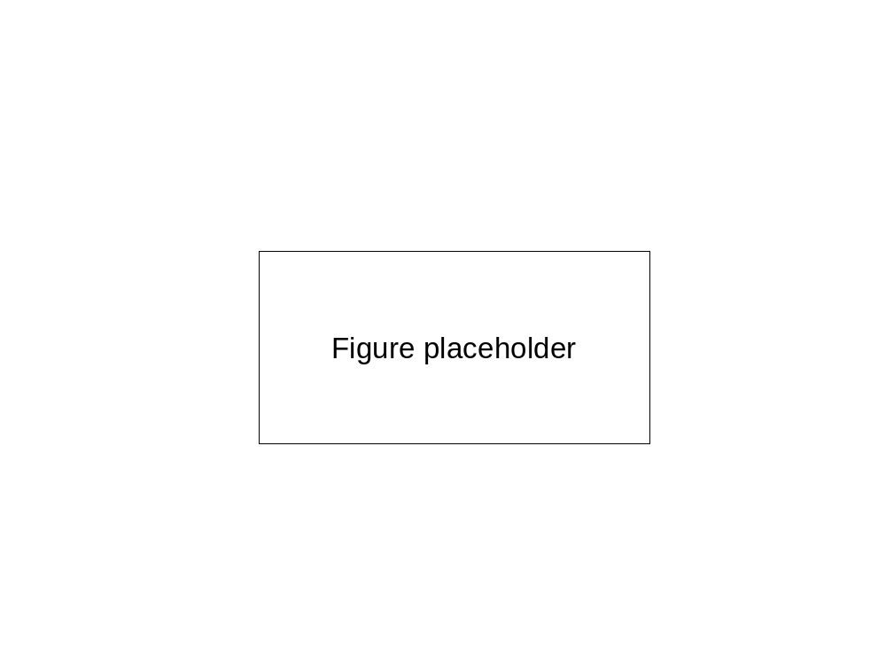
Figure 6. Resource Capabilities XML/XQuery Rendering Example

Representation of requirements
A job’s or activity’s requirements are expressed using XQuery. The XQuery language is a fairly complete algebra with many comparison and arithmetic operators that are needed to express requirements both as single values and ranges of values. User defined function and prologues can be exploited to use of XQuery specified requirements simpler to write. Implementation of a resource repository to hold a job’s or activity’s requirements may be either a native XML document store or a database. These queries work against XML documents – those documents that express resource capabilities. Because typing an XML document of XQuerys can be tedious and error-prone, this representation and its characteristics for specifying requirements was chosen to capitalize on existing tooling for generation and validation to quickly seed adoption.
Since XQuery is really an XML programming language, a profile of XQuery needs to be defined to restrict its usage to a reasonable and usable subset for expressing requirements to obtain implementation and deployment. **We could suggest the elements of the profile in appendix, but the definitive profile is best written in a separate document because a profile is normative (on the recommendation track) where as this document is informational.**
Figure 7 is an example of requirements specified using XQuery. *** Need to provide Figure 7 based on XML alignment of GLUE XML representation and OGSA advertisement structures. Propose that this example be a cleaned up version of some of the previous OGSA xQuery example charts (https://forge.gridforum.org/sf/go/doc14008?nav=1) that incorporate the English text example in section 4 of this document per section advertisement structure with GLUE XML representation. ***
Figure 7. Activity Requirements XML/XQuery Rendering Example

Basic set of resource capabilities and properties
The basic set of resource capabilities and properties for OGSA information model is GLUE [GLUE] supplemented with BES resource capabilities and properties [BES]. A JSDL document [JSDL] provides an activity’s requirements.

Security Considerations
Use of managed information in models is subject to an activity’s authentication and authorization to use those resources. That authentication and authorization is outside the scope of this proposal. It is the responsibility of the security subsystem and protocols.

Appendix
Appendix 7.A: Requirements specification use cases to drive any intermediate steps and XQuery / Xpath suggested profile elements. Suggested use case items to address:
- jsdl 1.0
- jsdl 1.0 + extension for ‘and’ only requirements
- ‘or’ requirements: A or B
- ‘preferences’: RedHat over any Linux
- ‘weighting’:
- ‘optionality’:
Appendix 7.B: Major/viable intermediate steps. End-game in main-line text.
Appendix 7.C: XQuery / Xpath profile elements suggested. Normative profile in separate document.

Contributors

Ellen Stokes
IBM
11400 Burnet Rd
Austin, TX 78758
stokese@us.ibm.com
+1 512 778 5821

Other contributors include members of the OGF OGSA, Reference Model, GLUE, BES, and JSDL workgroups.

Intellectual Property Statement
The OGF takes no position regarding the validity or scope of any intellectual property or other rights that might be claimed to pertain to the implementation or use of the technology described in this document or the extent to which any license under such rights might or might not be available; neither does it represent that it has made any effort to identify any such rights. Copies of claims of rights made available for publication and any assurances of licenses to be made available, or the result of an attempt made to obtain a general license or permission for the use of such proprietary rights by implementers or users of this specification can be obtained from the OGF Secretariat.
The OGF invites any interested party to bring to its attention any copyrights, patents or patent applications, or other proprietary rights which may cover technology that may be required to practice this recommendation. Please address the information to the OGF Executive Director.

Disclaimer
This document and the information contained herein is provided on an “As Is” basis and the OGF disclaims all warranties, express or implied, including but not limited to any warranty that the use of the information herein will not infringe any rights or any implied warranties of merchantability or fitness for a particular purpose.

Full Copyright Notice
Copyright ® Open Grid Forum (2006-2007). All Rights Reserved.
This document and translations of it may be copied and furnished to others, and derivative works that comment on or otherwise explain it or assist in its implementation may be prepared, copied, published and distributed, in whole or in part, without restriction of any kind, provided that the above copyright notice and this paragraph are included on all such copies and derivative works. However, this document itself may not be modified in any way, such as by removing the copyright notice or references to the OGF or other organizations, except as needed for the purpose of developing Grid Recommendations in which case the procedures for copyrights defined in the OGF Document process must be followed, or as required to translate it into languages other than English.
The limited permissions granted above are perpetual and will not be revoked by the OGF or its successors or assignees.

References
** Need updating**
[CIM2.16final] CIM Schema, Version 2.16 Final, Distributed Management Task Force, August 2007, http://www.dmtf.org/standards/cim/cim_schema_v216
[CIM2.16exp] CIM Schema, Version 2.16 Experimental, Distributed Management Task Force, August 2007, http://www.dmtf.org/standards/cim/cim_schema_v216
[CIMspec] “CIM Infrastructure Specification, Version 2.3“, Distributed Management Task Force, October 4, 2005, http://www.dmtf.org/standards/documents/CIM/DSP0004.pdf
[CIMOPS] “Specification for CIM Operations over HTTP, Version 1.2”, DSP0200, Distributed Management Task Force, January 9, 2007, http://www.dmtf.org/standards/published_documents/DSP200.html
[BES] I. Foster, A. Grimshaw, P. Lane, W. Lee, M. Morgan, S. Pickles, D. Pulsipher, C. Smith, M. Theimer, “OGSA Basic Execution Services, Version 1.0”, Open Grid Forum, GFD.108, July 2006, http://www.ogf.org/gf/docs/?final
[GLUE] <insert reference>
[JSDL] <insert reference>

Although one can distinguish between a resource and a service, for brevity in this paper the term resource includes both resources and services.

